**AY2016 Semester 2**

|  |  |  |  |
| --- | --- | --- | --- |
| Name |  | | |
| Student ID |  | | |
| Assessment Venue |  | Seat Number |  |

**E331 ESE**



E331 Supply Chain Management

**AY2016 Semester 2 End - Semester Examination (ESE)**

|  |  |  |
| --- | --- | --- |
| ***This segment is to be used by staff grader(s) only.*** | | |
| **Question Number** | **Marks Awarded** | **Max Marks** |
| **1** |  | **21** |
| **2** |  | **15** |
| **3** |  | **17** |
| **4** |  | **14** |
| **5** |  | **15** |
| **6** |  | **18** |
|  |  |  |
|  |  |  |
|  |  |  |
|  |  |  |
|  |  |  |
|  |  |  |
|  |  |  |
|  |  |  |
|  |  |  |
|  |  |  |
|  |  |  |
|  |  |  |
|  |  |  |
| **Total** |  | **100** |

|  |  |
| --- | --- |
| **Instructions to student:** | |
| 1) | Do not turn over this question paper until you are instructed to do so by the invigilator. |
| 2) | Write your name, student ID, assessment venue and seat number in the table provided at the top of each page. |
| 3) | For this question paper, there are **16** pages (including this cover page). |
| 4) | For this assessment, you are allowed to:   * Refer to materials stored in your laptop. * Have a blank piece of paper for rough working purpose. (Note that the sheet of rough working paper will not be accepted for submission at the end of the assessment.) |
| 5) | For this assessment, you are **NOT** allowed to:   * Refer to written materials including textbooks and hardcopy notes. * Share any material, such as calculators, with another student. * Communicate with any person other than the invigilator. * Use any communication devices such as handphone or smart watches while at the assessment venue. |
| 6) | All rules and regulations pertaining to summative assessments and academic integrity stated in the Student Handbook shall also apply. |

|  |  |  |
| --- | --- | --- |
| ***This segment is to be used by the invigilator only.*** | | |
| Please tick the box below if the student has done part of the assessment online: | Invigilator’s Name: | Invigilator’s Signature: |
| Partially done online |  |  |

Page 1 of 16

# Question 1 [21 Marks]

Panda Imaging Limited is a manufacturer of high-end digital printing machine for commercial and industrial application, with a price starting at around $100,000.

Panda Imaging’s printing machine is bulky, complex and highly customized to meet specific customer requirements. The demand is low. Currently Panda has only one manufacturing plant in Thailand. The delivery time to the customer from the actual order received is around 2 months and customer is satisfied with current waiting time. Full installation and setup at customer site are required.

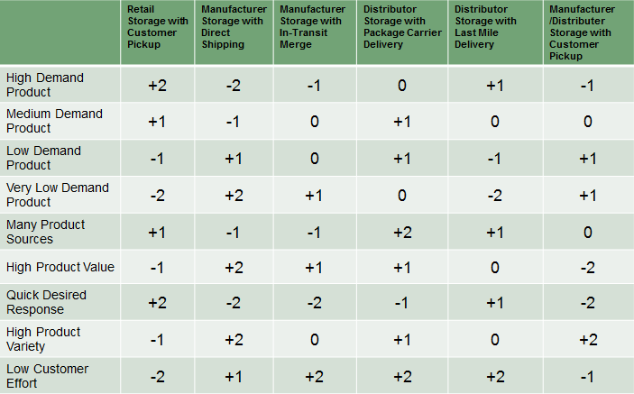Table 1.1. Delivery Networks for Product Characteristics & Customer Preferences

1. Based on above description and table 1.1, identify **TWO (2)** relevant product characteristics for Panda Imaging’s printing machine. (2 marks)
2. In order to select the right distribution network design, the company needs to shortlist the customer service factors that matter to them. Name **TWO (2)** service factors that are important to the company. (2 marks)
3. The company is interested in two distribution network designs for the printing machine, “Manufacturing Storage with Direct Shipping” and “Distributor Storage with Package Carrier Delivery”. Which one is better? Show your quantitative workings to justify. (3 marks)
4. Panda Imaging’s management wishes to improve its Cash-to-Cash Cycle Time to be better than its competitors. What is Cash-to-Cash Cycle Time? (2 marks)
5. Table 1.2 summarizes the financial data extracted from the company’s Income Statement and Balance Sheet. Fiscal year ends on 31 December. It is assumed that there are 365 days in a year.

Table 1.2. Financial Data (All $ amounts in millions)

|  |  |  |
| --- | --- | --- |
| From Income Statement | **FY 2015** | **FY 2016** |
| Cost of Goods Sold | $380 | $450 |
| Net Sales | $1200 | $1500 |
| From Balance Sheet | **FY 2015** | **FY 2016** |
| Accounts Payable | $100 | $300 |
| Accounts Receivable | $300 | $200 |
| Inventory | $220 | $230 |

Calculate the value of working capital in FY2015. Show your key workings and round up your answer to the nearest integer. (2 marks)

1. Calculate the Cash-to-Cash Cycle Time in FY 2016 if we know the Days Sales Outstanding is 61 days. Show your key workings and round up your answers to the nearest integer. (5 marks)
2. If the Inventory Days of Supply is 300 days in FY2015, which year (FY2015 or FY2016) did the company perform better in terms of Inventory Days of Supply? State **ONE (1)** reason to justify your answer. (2 marks)
3. Comparing the “Manufacturing Storage with Direct Shipping” with “Distributor Storage with Package Carrier Delivery”, which one can help the company perform better on Inventory Days of Supply? Provide **ONE (1)** reason. (3 marks)

# Question 2 [15 Marks]

CakeK is a bakery chain that sells a wide range of [bread](http://en.wikipedia.org/wiki/Bread), [cakes](http://en.wikipedia.org/wiki/Cake) and [pastries](http://en.wikipedia.org/wiki/Pastry). The bakery supplies are delivered from the central warehouse to each retail shop on a weekly basis.

Due to the rising operating costs, the manager is looking into the possibility of using Milk Run in their delivery planning.

1. Explain how Milk Run helps improve the delivery routing in **TWO (2)** ways.

(2 marks)

1. The delivery order size, distance matrix and distance saving matrix are given in the following tables. Find the missing numbers indicated as **a** and **b** in Table 2.2 and 2.3, respectively.

(4 marks)

Table 2.1. Delivery Order Size

|  |  |
| --- | --- |
|  | Order size |
| Shop 1 | 85 |
| Shop 2 | 80 |
| Shop 3 | 95 |
| Shop 4 | 75 |
| Shop 5 | 65 |
| Shop 6 | 60 |
| Shop 7 | 85 |

Table 2.2. Distance Matrix

|  |  |  |  |  |  |  |  |  |
| --- | --- | --- | --- | --- | --- | --- | --- | --- |
|  | **WH** | **Shop 1** | **Shop 2** | **Shop 3** | **Shop 4** | **Shop 5** | **Shop 6** | **Shop 7** |
| **WH** | 0 |  |  |  |  |  |  |  |
| **Shop 1** | 6 | 0 |  |  |  |  |  |  |
| **Shop 2** | 5 | 8 | 0 |  |  |  |  |  |
| **Shop 3** | 8 | 7 | 7 | 0 |  |  |  |  |
| **Shop 4** | 10 | 7 | 9 | 6 | 0 |  |  |  |
| **Shop 5** | 9 | 9 | 7 | **a** | 9 | 0 |  |  |
| **Shop 6** | 12 | 9 | 10 | 6 | 5 | 8 | 0 |  |
| **Shop 7** | 15 | 10 | 10 | 7 | 8 | 5 | 5 | 0 |

Table 2.3. Distance Saving Matrix

|  |  |  |  |  |  |  |  |
| --- | --- | --- | --- | --- | --- | --- | --- |
|  | **Shop 1** | **Shop 2** | **Shop 3** | **Shop 4** | **Shop 5** | **Shop 6** | **Shop 7** |
| **Shop 1** | 0 |  |  |  |  |  |  |
| **Shop 2** | 3 | 0 |  |  |  |  |  |
| **Shop 3** | 7 | 6 | 0 |  |  |  |  |
| **Shop 4** | 9 | 6 | 12 | 0 |  |  |  |
| **Shop 5** | 6 | 7 | 13 | 10 | 0 |  |  |
| **Shop 6** | 9 | 7 | 14 | 17 | 13 | 0 |  |
| **Shop 7** | 11 | 10 | 16 | **b** | 19 | 22 | 0 |

1. Currently CakeK has only 2 trucks with a capacity of 300 standard carton boxes each. Apply the Saving Matrix Method to identify the routes for both trucks as well as the total truck loads. (6 marks)
2. If the truck capacity could be increased from 300 to 550 carton boxes, how many trucks are required to deliver to all 7 shops?

Based on Table 2.2 Distance Matrix, determine the sequenced route by using the nearest neighbour method. (3 marks)

# Question 3 [17 Marks]

Heli is a producer and distributor of white goods, headquartered in Shenzhen, China. It has been consecutively ranked as China’s most valuable brand for home appliance and kitchen appliance.

1. As the industry leader, Heli is keen to improve its supply chain performance, and SCOR is the latest tool that they just implemented. Name **TWO (2)** performance attributes that SCOR model identifies. (2 marks)
2. As a producer of white goods, Make process is key. Which level 2 Make process is representative of the company’s manufacturing process?

What are the metrics recommended for this level 2 Make process in terms of Supply Chain Costs? (3 marks)

1. If the company values the responsiveness of its supply chain, which level 1 metric should they look into?

Name **TWO (2)** immediate diagnostic metrics of it. (3 Marks)

1. What is the name of the SCOR metric RL.1.1?

Calculate this metric based on below information and round up your answer to 2 decimal places. (3 Marks)

* + Total number of orders delivered to customers = 1500
  + Total number of orders delivered on time to customers = 1250
  + Total number of orders with missing documentation = 100
  + Total number of orders with shipping damage = 50

1. Due to the size and weight, distribution costs of white goods products are much higher than others. Describe **TWO (2)** ways that can green the distribution.

(2 Marks)

1. Besides distributing products to retailers, the company is investigating the option of doing home deliveries from the manufacturer itself. Name **TWO (2)** initiatives that can make its transportation green and sustainable. (2 Marks)
2. With increasing white goods products being discarded every year, the potential for recycling is going up as well. Suggest **TWO (2)** good practices that could be adopted to green the reverse logistics. (2 Marks)

# Question 4 [14 Marks]

*The following questions are related to SAP Sales and Distribution (SD) module.*

LifeSavers manufactures and distributes over 2,000 safety equipment and accessory items related to sea sports & water activities. It has manufacturing operations in both America and Germany, two factories in America and another factory in Germany.

All its factories have separate storage areas for raw materials, WIP, finished goods and spare parts. The New York office in America centralizes the sales operations where they sell via retailers.

1. Name **THREE (3)** organizational units that should be used in SAP system according to above description. (3 marks)
2. Which of the followings represents the correct order of steps performed in SAP order-to-cash cycle? (2 marks)
   1. Creating Sales Order --> Checking availability --> Goods Issue --> Outbound delivery order --> Billing
   2. Creating Sales Order --> Goods Issue --> Outbound delivery order -->

Checking availability --> Billing

* 1. Checking availability --> Creating Sales Order --> Billing --> Goods Pickup -->

Outbound delivery

* 1. Creating Sales Order --> Checking availability --> Outbound delivery order --> Goods Issue --> Billing

1. The New York office is in charge of creating sales documents in SAP for all its factories. List **THREE (3)** key information that should be entered when creating a sales order. (3 marks)
2. Which Partner Functions are required in the header of a sales order? (2 marks)
3. Post Good Issue is the last step in delivery processing. Name **TWO (2)** effects of post good issue. (2 marks)
4. Describe how Document Flow helps the staff in New York office to track the sales order processing status. (2 marks)

# Question 5 [15 Marks]

*The following questions are related to SAP Materials Management (MM) module.*

Darren is the Purchase Manager of LifeSavers. Similar to the New York office, his department is handling the purchases for all factories in both America and Germany. The buyers from the factories have to raise purchase requisitions (PR) and then Darren’s department will create the purchase orders (PO).

The engineering department just fine tuned the design of one of its safety equipment. This modification requires the purchase of a new raw material and identification of a new vendor.

1. For the new Material Master to be created, what is the material type to be used?

(2 marks)

1. What are the **THREE (3)** categories of data that should be maintained when creating Vendor Master for the newly identified vendor? (3 marks)
2. Suppose a buyer happened to indicate the wrong requirement quantity when creating the Purchase Requisition, briefly explain the corrective actions that should be carried out to correct the requirement quantity. (2 marks)
3. A Purchase Order can be created with reference to a Purchase Requisition, what additional data are required to convert the PR into a PO? Name **TWO (2).**

(2 marks)

1. When performing the Goods Receipt with reference to a PO, what are the **TWO**

**(2)** necessary details that need to be entered in SAP system before you click on “Post” button? (2 marks)

1. Name **TWO (2)** effects of performing Goods Receipt in SAP system. (2 marks)
2. Which transaction can be used to monitor the stock status in the procurement process in SAP system? (2 marks)

# Question 6 [18 Marks]

Celina works as a material planner in VSupply, which is a major manufacturer of consumer electronic products. She is in charge of the inventory of the coffee makers.

The management targets a customer service level of 90% with a periodic review of its inventory every 4 weeks. Table 6.1 shows the historical sales data for year 2016. Replenishment lead time is long at 8 weeks. Assume there are 4 weeks in a month.

Table 6.1. Monthly Sales Figures

|  |  |  |  |  |  |  |  |
| --- | --- | --- | --- | --- | --- | --- | --- |
| **Monthly Sales (units)** | | | | | | | |
| Shipped-to | Product Model | Jul 16 | Aug 16 | Sep 16 | Oct 16 | Nov 16 | Dec 16 |
| Singapore | CM-S | 1100 | 1200 | 950 | 900 | 1500 | 1800 |
| Malaysia | CM-M | 1200 | 900 | 1050 | 800 | 1200 | 1000 |
| Thailand | CM-T | 1000 | 1100 | 850 | 900 | 1300 | 1200 |

1. What is the Coefficient of Variation for Singapore? What does COV measure? Round up your answer to 2 decimal places. (2 marks)
2. What is the safety stock required for Thailand if Build-To-Stock (BTS) strategy is in use? Round up your answer to the nearest integer. (3 marks)
3. What is the safety stock required if Configure-To-Order (CTO) strategy is adopted instead? Round up your answer to the nearest integer. (3 marks)
4. In terms of inventory saving, which country might benefit the most by changing from BTS strategy to CTO? Provide **ONE (1)** reason to justify. (2 marks)
5. RAP means keeping work-in-process items “as raw as possible”. Which supply chain design can achieve the greatest benefits from applying RAP? Provide **ONE**
   1. reason to justify. (2 marks)
6. According to the diagram below (among A, B, C and D), which one represents BTS and which one represents CTO? (4 marks)

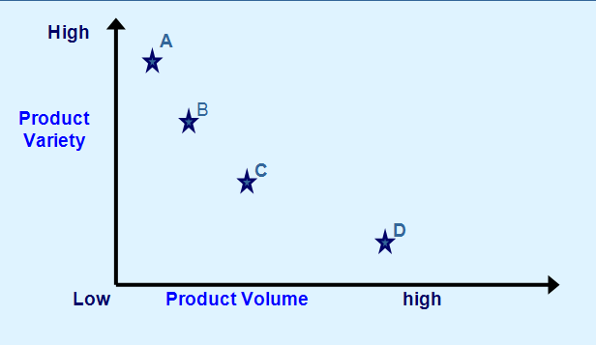

1. Recently the company received a customer feedback that the current lead time from order to delivery is too long. Will you recommend the Build-To-Order (BTO) strategy in such case? State **ONE (1)** reason. (2 marks)

**END OF PAPER**